Employee ID: 11949
Employee Name: Muthuraj Periyasamy

Date:12-01-2023

- Use your previous [ Angular, Spring Boot & Microservices ] lab assessment [dated 19-Dec-2023] project / application to write the following test cases.

White Box Testing (Unit Testing) : [ 2 + 2 = 4 Hours ]
- Write the Unit Test cases by using JUnit for your Back-End [Spring Boot].
- Write the Unit Test cases by using Jasmine & Karma for your Front-End [Angular].
1.Write the Unit Test cases by using JUnit for your Back-End [Spring Boot]

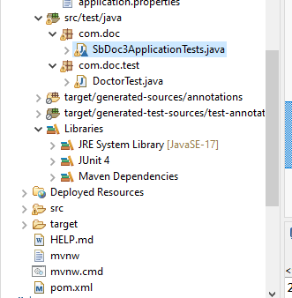

Package name - com.doc.test
Class name - DoctorTest

package com.doc.test;
import static org.junit.Assert.*;
import java.util.ArrayList;
import java.util.List;
import java.util.Optional;
import org.junit.Test;
import org.springframework.boot.autoconfigure.SpringBootApplication;
import com.doc.bean.Doctor;
import com.doc.controller.DOCController;
import com.doc.dao.DoctorDAO;
import static org.junit.Assert.*;
import org.junit.After;
import org.junit.AfterClass;
import org.junit.Before;
import org.junit.BeforeClass;
import org.junit.Test;
import org.springframework.test.annotation.Rollback;
import org.assertj.core.api.Assertions;
import org.junit.jupiter.api.MethodOrderer;
import org.junit.jupiter.api.Order;
@SpringBootApplication
public class DoctorTest {

private DOCController controller;
private Doctor doctor;
private DoctorDAO doctordao;

@Test
@Order(1)
@Rollback(value = false)
public void testPerformInsert(){
Doctor obj=new Doctor();
obj.setdId(1);
obj.setdName("raja");
obj.setdAge(23);
obj.setdEmail("raja@gmail.com");
obj.setdSpecialization("Baby");
obj.setdPhno(678976);
obj.setdLocation("chennai");
obj=controller.performInsert(doctor);
org.junit.Assert.assertEquals(obj, doctor);
}
@After
@Order(2)
@Rollback(value = false)
public void testPerformUpdate(){
Doctor obj=new Doctor();
obj.setdId(1);
obj.setdName("kannan");
obj.setdAge(23);
obj.setdEmail("kannan@gmail.com");
obj.setdSpecialization("Baby");
obj.setdPhno(678976);
obj.setdLocation("chennai");
obj=controller.performInsert(doctor);
org.junit.Assert.assertEquals(obj, doctor);
}
@Test
@Order(3)
@Rollback(value = false)
public void testPeformDelete(){
Doctor obj=new Doctor();
Doctor doctor = null;
Optional<Doctor> optionalDoctor = doctor();
if(optionalDoctor.isPresent()){
doctor = optionalDoctor.get();
}
Assertions.assertThat(doctor).isNull();
}
@Test
@Order(4)
public void testPeformGetId(){
Doctor obj=new Doctor();
Assertions.assertThat(obj.getdId()).isEqualTo(1L);
}
@Test
@Order(5)
public void getListOfDoctorTest(){
List<Doctor> list = new ArrayList<Doctor>();
Assertions.assertThat(list.size()).isGreaterThan(0);
}
private Optional<Doctor> doctor() {
// TODO Auto-generated method stub
return null;
}
}

Output:

